**Modul 5**

Nama : Andrias Sigid W.R

NIM : L200144010

Percobaan 1

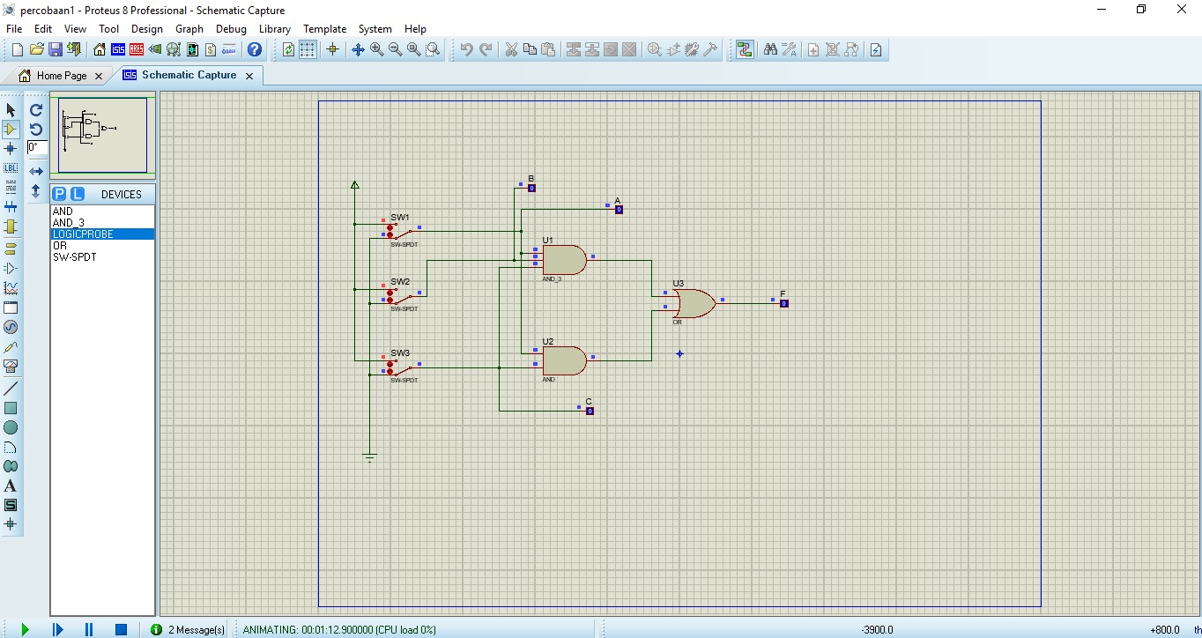

|  |  |  |  |
| --- | --- | --- | --- |
| A | B | C | F |
| 0 | 0 | 0 | 0 |
| 1 | 0 | 0 | 0 |
| 0 | 1 | 0 | 0 |
| 1 | 1 | 0 | 0 |
| 0 | 0 | 1 | 0 |
| 1 | 0 | 1 | 1 |
| 0 | 1 | 1 | 0 |
| 1 | 1 | 1 | 1 |

Karnaugh Map

|  |  |  |  |  |  |
| --- | --- | --- | --- | --- | --- |
|  | | AB | | | |
| 00 | 01 | 11 | 10 |
| C | 1 | 0 | 0 | 0 | 0 |
| 0 | 0 | 0 | 1 | 0 |

F = AC

Percobaan 2

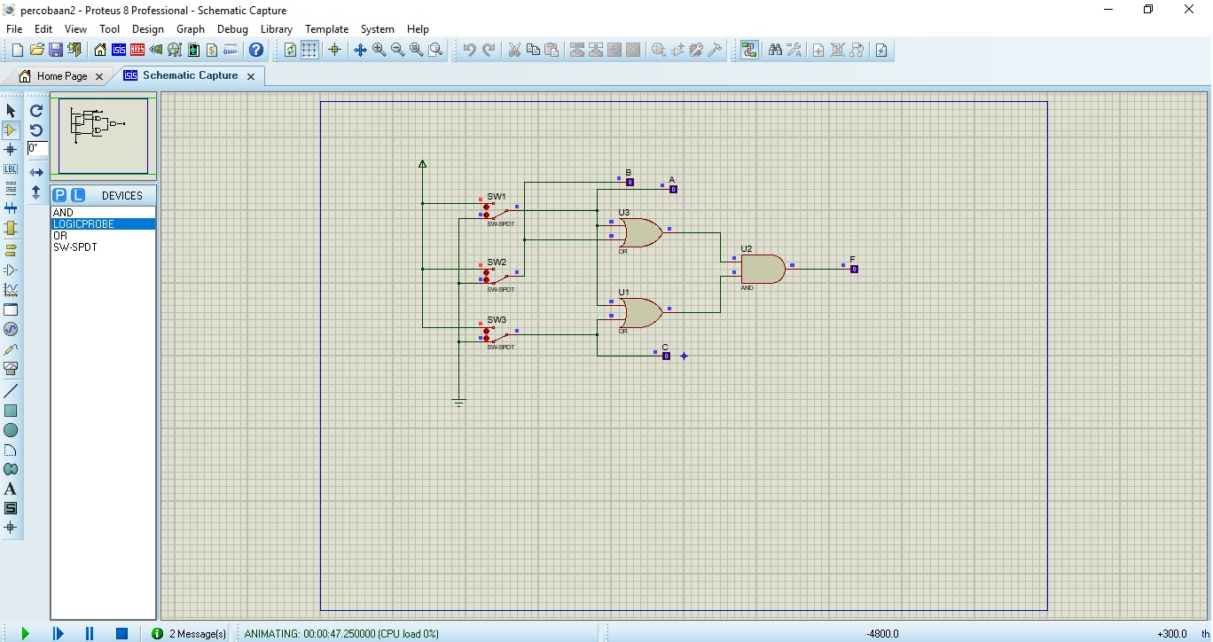

3.

|  |  |  |  |
| --- | --- | --- | --- |
| A | B | C | F |
| 0 | 0 | 0 | 0 |
| 1 | 0 | 0 | 1 |
| 0 | 1 | 0 | 0 |
| 1 | 1 | 0 | 1 |
| 0 | 0 | 1 | 0 |
| 1 | 0 | 1 | 1 |
| 0 | 1 | 1 | 1 |
| 1 | 1 | 1 | 1 |

4. Karnaugh Map

|  |  |  |  |  |  |
| --- | --- | --- | --- | --- | --- |
|  | | AB | | | |
| 00 | 01 | 11 | 10 |
| C | 0 | 0 | 0 | 1 | 1 |
| 1 | 0 | 1 | 1 | 1 |

5. F = (A+BC)

Percobaan 3

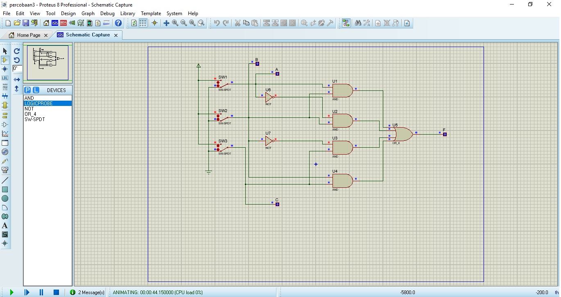

3.

|  |  |  |  |
| --- | --- | --- | --- |
| A | B | C | F |
| 0 | 0 | 0 | 0 |
| 1 | 0 | 0 | 0 |
| 0 | 1 | 0 | 1 |
| 1 | 1 | 0 | 1 |
| 0 | 0 | 1 | 1 |
| 1 | 0 | 1 | 1 |
| 0 | 1 | 1 | 1 |
| 1 | 1 | 1 | 1 |

4.Karnaugh Map

|  |  |  |  |  |  |
| --- | --- | --- | --- | --- | --- |
|  | | AB | | | |
| 00 | 01 | 11 | 10 |
| C | 0 | 0 | 1 | 1 | 0 |
| 1 | 1 | 1 | 1 | 1 |

5. F = B + C